BANK LOAN REPORT QUERY DOCUMENT
- BANK LOAN REPORT | SUMMARY
KPIs
Total Loan Applications
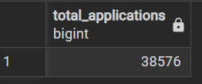
select count(id) as Total_Applications from bank_loan_data;

MTD Loan Applications
select count(id) as MTD_Total_Applications from bank_loan_data
where EXTRACT(MONTH FROM issue_date)=12;
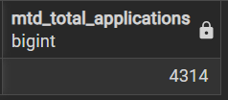

PMTD Loan Applications
select count(id) as PMTD_Total_Applications from bank_loan_data
where EXTRACT(MONTH FROM issue_date)=11;
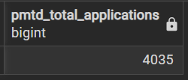

Total Funded Amount
select sum(loan_amount) as Total_Funded_Amount from bank_loan_data;
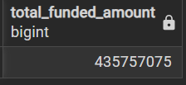

MTD Total Funded Amount
select sum(loan_amount) as MTD_Total_Applications from bank_loan_data
where EXTRACT(MONTH FROM issue_date)=12;
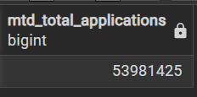

PMTD Total Funded Amount
select sum(loan_amount) as PMTD_Total_Applications from bank_loan_data
where EXTRACT(MONTH FROM issue_date)=11;
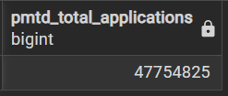

Total Received Amount
SELECT SUM(total_payment) as Total_received_amount FROM bank_loan_data;
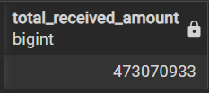

MTD Total Received Amount
select sum(total_payment) as MTD_otal_received_amount from bank_loan_data
where EXTRACT(MONTH FROM issue_date)=12;
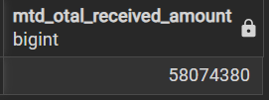

MTD Total Received Amount
select sum(total_payment) as PMTD_otal_received_amount from bank_loan_data
where EXTRACT(MONTH FROM issue_date)=11;
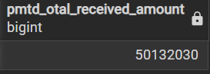
Average Interest Rate
select round((avg(int_rate)*100),2) as Average_interest_rate from bank_loan_data;
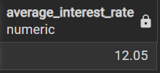

MTD Average Interest Rate
select round((avg(int_rate)*100),2) as Average_interest_rate from bank_loan_data
where EXTRACT(MONTH FROM issue_date)=12;
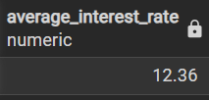

PMTD Average Interest Rate
select round((avg(int_rate)*100),2) as Average_interest_rate from bank_loan_data
where EXTRACT(MONTH FROM issue_date)=11;
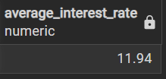

Average DTI
select round((avg(dti)*100),2) as Average_dti from bank_loan_data;
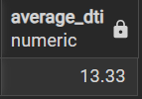

Average MTD DTI
select round((avg(dti)*100),2) as MTD_Average_dti from bank_loan_data
where EXTRACT(MONTH FROM issue_date)=12;
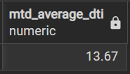
Average PMTD DTI
select round((avg(dti)*100),2) as PMTD_Average_dti from bank_loan_data
where EXTRACT(MONTH FROM issue_date)=11;
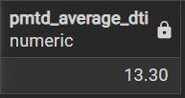

Good Loan Issued
Good Loan Percentage
SELECT
(COUNT(CASE WHEN loan_status = 'Fully Paid' OR loan_status = 'Current' THEN id END) * 100.0) /
COUNT(id) AS Good_Loan_Percentage
FROM bank_loan_data;
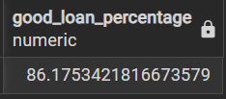

Good Loan Applications
SELECT COUNT(id) AS Good_Loan_Applications FROM bank_loan_data
WHERE loan_status = 'Fully Paid' OR loan_status = 'Current';
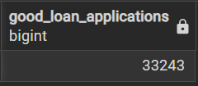

Good Loan Funded Amount
SELECT sum(loan_amount) AS Good_Loan_Funded_Amount FROM bank_loan_data
WHERE loan_status = 'Fully Paid' OR loan_status = 'Current';
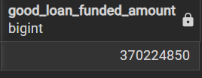

Good Loan Amount Received
SELECT sum(total_payment) AS Good_Loan_Amount_Received FROM bank_loan_data
WHERE loan_status = 'Fully Paid' OR loan_status = 'Current';
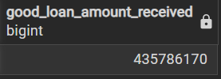

Bad Loan Issued
Bad Loan Percentage
SELECT
(COUNT(CASE WHEN loan_status = 'Charged Off' THEN id END) * 100.0) /
COUNT(id) AS Bad_Loan_Percentage
FROM bank_loan_data;
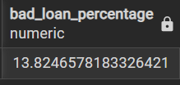

Bad Loan Applications
SELECT COUNT(id) AS Bad_Loan_Applications FROM bank_loan_data
WHERE loan_status = 'Charged Off';
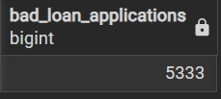

Bad Loan Funded Amount
SELECT sum(loan_amount) AS Bad_Loan_Funded_Amount FROM bank_loan_data
WHERE loan_status = 'Charged Off';
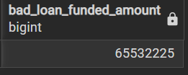

Bad Loan Amount Received
SELECT sum(total_payment) AS Bad_Loan_Funded_Amount FROM bank_loan_data
WHERE loan_status = 'Charged Off';
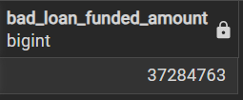

LOAN STATUS
SELECT
loan_status,
COUNT(id) AS LoanCount,
SUM(total_payment) AS Total_Amount_Received,
SUM(loan_amount) AS Total_Funded_Amount,
AVG(int_rate * 100) AS Interest_Rate,
AVG(dti * 100) AS DTI
FROM
bank_loan_data
GROUP BY
loan_status;
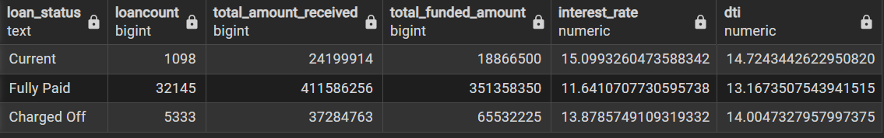

SELECT
loan_status,
SUM(total_payment) AS MTD_Total_Amount_Received,
SUM(loan_amount) AS MTD_Total_Funded_Amount
FROM bank_loan_data
WHERE EXTRACT(MONTH FROM issue_date) = 12
GROUP BY loan_status;
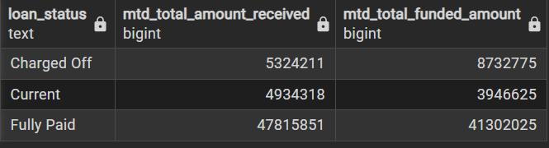

- BANK LOAN REPORT | OVERVIEW

MONTH
SELECT
EXTRACT(MONTH FROM issue_date) AS Month_Munber,
TO_CHAR(issue_date, 'Month') AS Month_name,
COUNT(id) AS Total_Loan_Applications,
SUM(loan_amount) AS Total_Funded_Amount,
SUM(total_payment) AS Total_Amount_Received
FROM bank_loan_data
GROUP BY EXTRACT(MONTH FROM issue_date), TO_CHAR(issue_date, 'Month')
ORDER BY EXTRACT(MONTH FROM issue_date);
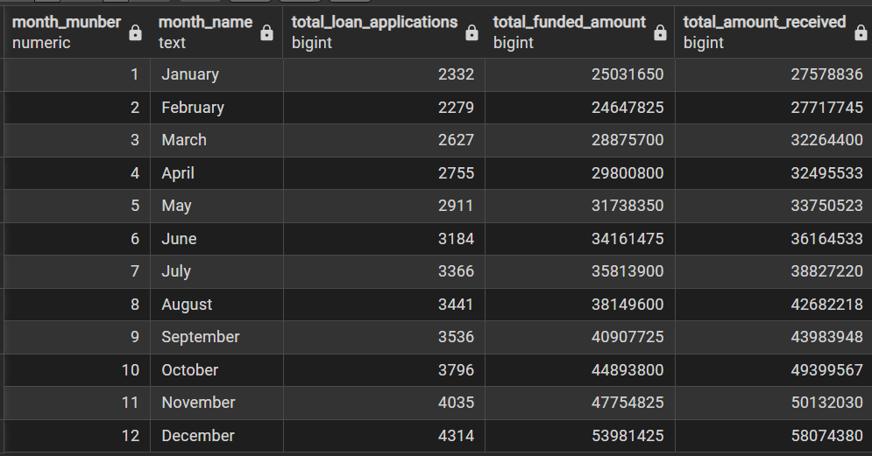

STATE
Select
address AS State,
COUNT(id) AS Total_Loan_Applications,
SUM(loan_amount) AS Total_Funded_Amount,
SUM(total_payment) AS Total_Amount_Received
FROM bank_loan_data
GROUP BY address ORDER BY address;
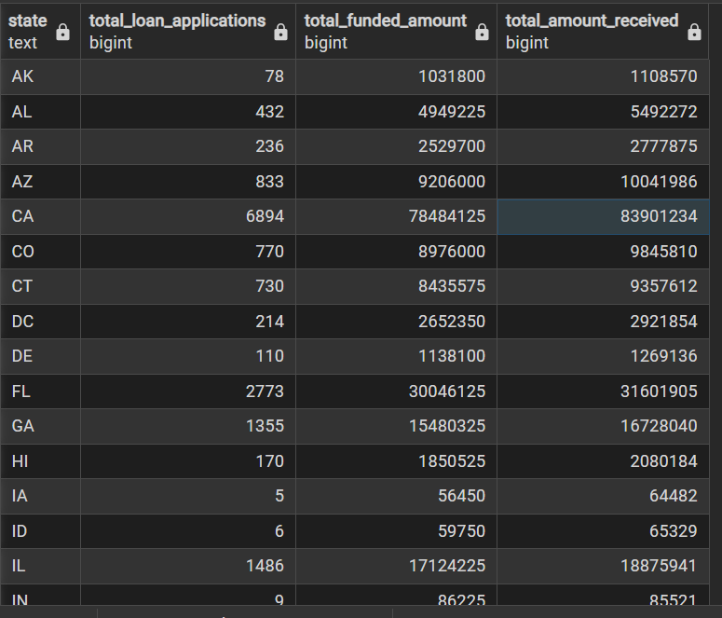
TERM
SELECT
term AS Term,
COUNT(id) AS Total_Loan_Applications,
SUM(loan_amount) AS Total_Funded_Amount,
SUM(total_payment) AS Total_Amount_Received
FROM bank_loan_data
GROUP BY term
ORDER BY term;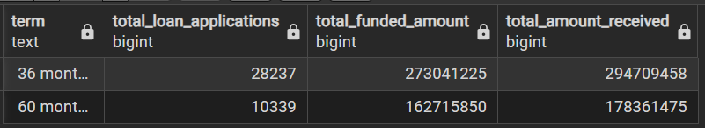
EMPLOYEE LENGTH
SELECT
emp_length AS Employee_Length,
COUNT(id) AS Total_Loan_Applications,
SUM(loan_amount) AS Total_Funded_Amount,
SUM(total_payment) AS Total_Amount_Received
FROM bank_loan_data
GROUP BY emp_length
ORDER BY emp_length;
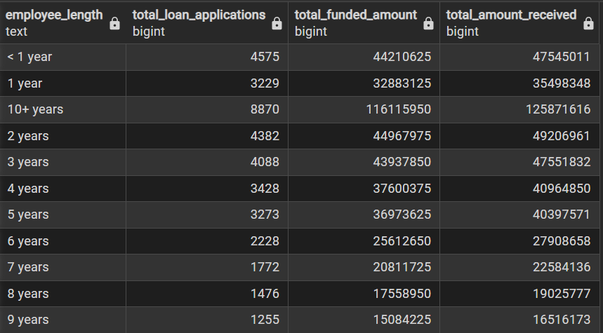

PURPOSE
SELECT
purpose AS PURPOSE,
COUNT(id) AS Total_Loan_Applications,
SUM(loan_amount) AS Total_Funded_Amount,
SUM(total_payment) AS Total_Amount_Received
FROM bank_loan_data
GROUP BY purpose
ORDER BY purpose;
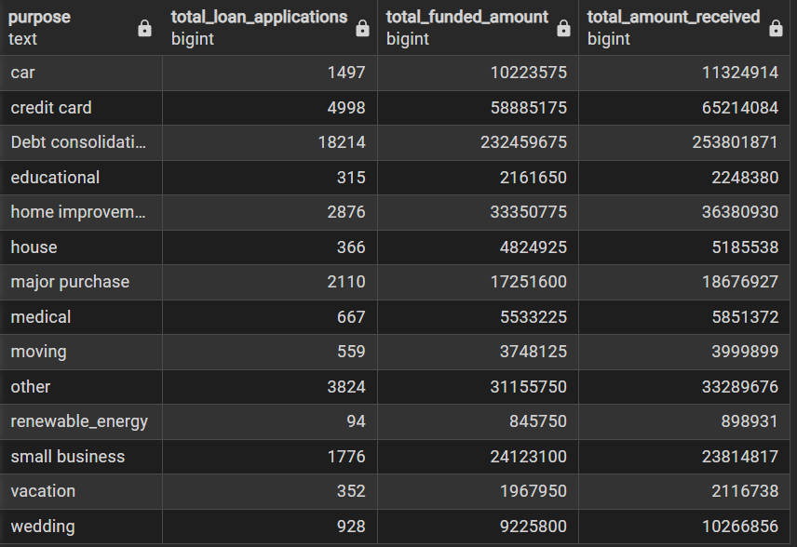

HOME OWNERSHIP
SELECT
home_ownership AS Home_Ownership,
COUNT(id) AS Total_Loan_Applications,
SUM(loan_amount) AS Total_Funded_Amount,
SUM(total_payment) AS Total_Amount_Received
FROM bank_loan_data
GROUP BY home_ownership
ORDER BY home_ownership;
